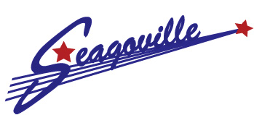
City of Seagoville, TX 702 N HWY 175 Seagoville, TX 75159

Public Hearing Notice
Zoning Board of Adjustments
City of Seagoville, Texas
#V2025-02

Canceled Due to Applicant Withdrawal

In accordance with Chapter 211 of the Texas Local Government Code, a Public Hearing will be held by the Zoning Board of Adjustments on Thursday, September 25, 2025, at 6:30 p.m. in the City Council Chambers at 702 N US Highway 175, Seagoville, TX, for the purpose of receiving testimony and comments on a variance request from, Section 25.02.153 of the City’s Zoning Ordinance for a variance of (18.5’) feet for the width of the lot located at 503 Netherland Dr, Seagoville, Texas. (Property Legal Description: Block 1 Lot 16 of the Phillip Pirozzo Unrec as recorded by the Deed Records of Dallas County, Texas.)

All Persons interested in the above-reference variance request are invited to attend the public hearing and to provide their comments at that time.

Collin Parks, City Planner
City of Seagoville • 702 N US Highway 175 • Seagoville, Texas 75159 • (972) 287-3918

